**Multimedia Editor and Compositor**

I am a part of a team that gives life to images, sounds, textures, to multimedia and virtual reality involving ourselves in new interactions.

Some of the tools that I have utilized over the years such as Adobe Photoshop Illustrator, OpenShot video editor, Microsoft’s Movie Creator, Adobe Premiere Pro CC and Coreldraw image editor just to name a few has been beneficial in me honing my skills in the arts of multimedia design and compositing.

**Graphics Design and Editing**

(Photoshop graphics editing of myself with angel wings)



**Video editing and compositing using OpenShot software**

(Editing a promotions video for Wisynco’s Power Ade Energy Drink)

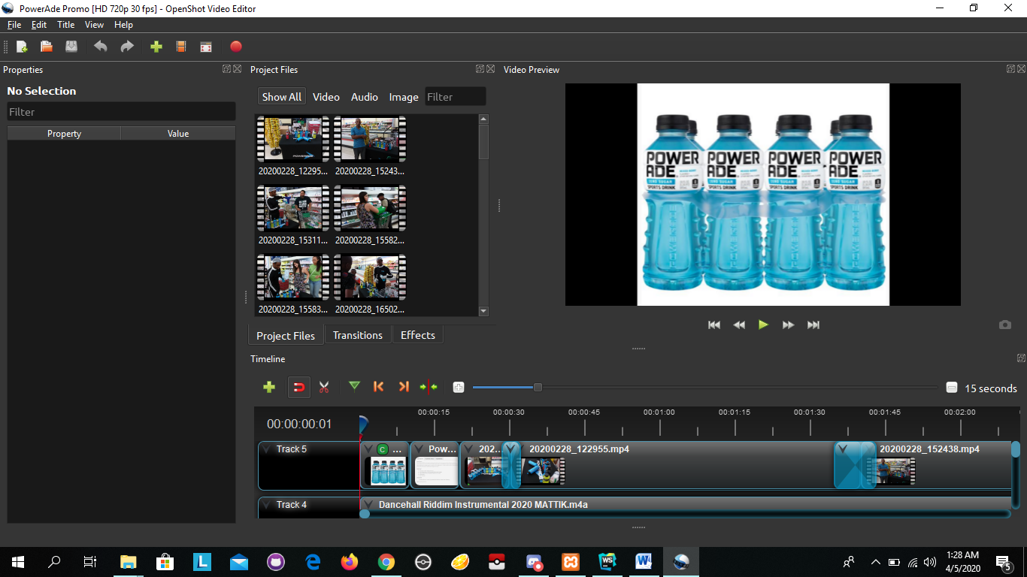

**Video Game Design**

I have recently started on my journey in learning then mastering video game design on the Unity platform.

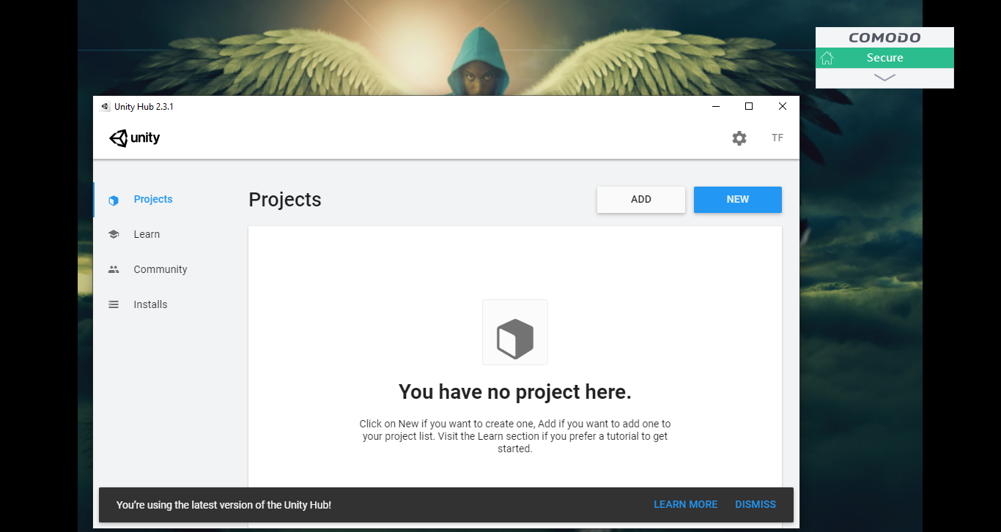

**Some benefits I have observed of the video game industry which drew me to game design are:**

1. Use my creative and analytical skills. Game designers are responsible for conceptualizing the themes, structure and rules of a video game—some specialize in more overtly creative areas such as scriptwriting or level design, while others work on game-play design or level mechanics. In either case, as a game designer you'll be using artistic and creative skills in addition to technological knowledge. Being analytical and organized is critical to planning how various aspects of the game will work—how a character confronts obstacles in the game, for instance, or how the player earns a score in relation to completing missions.

2. Work in an enthusiastic and casual environment. The game design culture is unlike the environment in any other industry. Employees are living their passion—they're dedicated, enthusiastic and creative, and as a game designer you get to experience the ultimate satisfaction of creating a product that you love and others will enjoy.

3. Enjoy a steady career in a dynamic industry. The game industry is always changing. There's never a dull moment, and you'll have the opportunity to learn throughout my career. At the same time, because the video game field is well established, I’ll enjoy the security of a steady job.

4. Earn a competitive salary. Game developers are part of the larger field of software developers. According to the U.S. Bureau of Labor Statistics' current Occupational Outlook Handbook, the median national annual salary for software developers is $102,280. Actual salaries may vary greatly based on specialization within the field, location, years of experience and a variety of other factors. National long-term projections of employment growth may not reflect local and/or short-term economic or job conditions, and do not guarantee actual job growth. Designers who work for game companies on the West Coast, which is a mecca for the game design industry, can expect an even higher average salary.

5. Make a career out of helping people have fun. Interactive entertainment is about more than just escapism—it's about people of all ages enjoying themselves in an immersive environment, whether it's a fantasy world or a sports field. As Electronic Arts' head of European talent acquisition Matthew Jeffery stated in an article for GameCareerGuide, "What job is better than helping people have fun?"

**Using the Unity Hub platform to create my first video game project**

